C++ Lambda Assignment
- Write a lambda expression that prints "Welcome to C++ Programming".
#include <iostream>
using namespace std;
int main() {
[] () {cout << "Welcome to C++ Programming" << endl;} ();
}

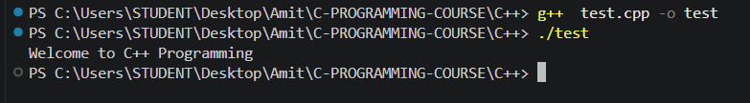
- Write a lambda expression that captures a variable by value and prints it.
#include <iostream>
using namespace std;
int main() {
int value = 50;
auto f = [value]() {cout << "Value: " << value << endl;};
f();
return 0;
}
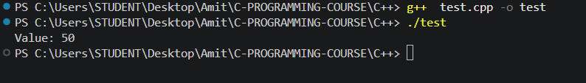
- Write a lambda expression that increases a variable by 10 using reference capture.
#include <iostream>
using namespace std;
int main() {
int number = 20;
auto increase = [&number]() {number += 10;};
increase();
cout << "After increase: " << number << endl;
return 0;
}
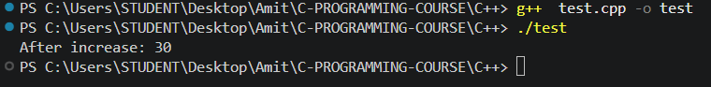
- Write a lambda expression that returns the square of a number.
#include <iostream>
using namespace std;
int main() {
int n;
cout << "Enter a number: ";
cin >> n;
auto square = [](int n) {return n * n;};
cout << "Square: " << square(n) << endl;
return 0;
}
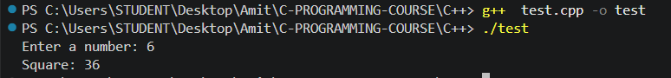
- Write a lambda expression that returns the larger of two numbers.
#include <iostream>
using namespace std;
int main() {
int a;
int b;
cout << "Enter a: ";
cin >> a;
cout << "Enter b: ";
cin >> b;
auto larger = [](int a, int b) {return (a > b) ? a : b;};
cout << "Larger: " << larger(a, b) << endl;
return 0;
}
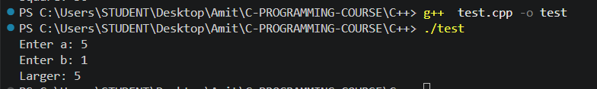
- Write a lambda expression that checks whether a number is even or odd.
#include <iostream>
using namespace std;
int main() {
auto evenOdd = [](int n) {
if (n % 2 == 0)
cout << n << " is Even" << endl;
else
cout << n << " is Odd" << endl;
};
evenOdd(7);
return 0;
}
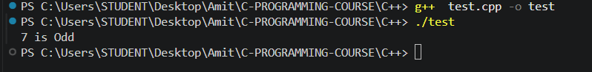
- Write a lambda that checks whether a number is positive, negative, or zero.
#include <iostream>
using namespace std;
int main() {
int n;
cout << "Enter a number: ";
cin >> n;
auto checkSign = [](int n) {
if (n > 0)
cout << "Positive" << endl;
else if (n < 0)
cout << "Negative" << endl;
else
cout << "Zero" << endl;
};
checkSign(n);
return 0;
}

